**L&T Technology Services Limited**

20

**Learning Report**

**Applied SDLC – Project: Smart Tools**

**Pradeep V (PS: 99002647)**

Table of Contents

1 Introduction 4

1.1 Purpose 4

1.2 Intended Audience and Reading Suggestions 4

1.3 Product Scope 4

1.4 References 4

2 Overall Description 5

2.1 Product Perspective 5

2.2 Product Functions 5

2.3 Operating Environment 5

3 High Level System Requirements 6

3.1 Menu Driven UI 6

3.2 Main Modules 6

4 Low Level System Requirement 7

4.1 System Feature 7

4.1.1 Menu 7

4.1.2 Calculator 7

4.1.3 Unit Convertor 7

5 Test Cases 11

6 Non-Functional Requirements 12

6.1 Performance Requirements 12

6.2 Safety requirements 12

**Table of Figures**

Figure 1: Component Diagram 7

Figure 2: Class Diagram 8

Figure 3: Usecase Diagram 9

Figure 4: Sequence Diagram 10

# Introduction

## Purpose

The purpose of this project entitled “Smart Tools” is to design and develop a software system that consists of multiple day to day tools like Calculator, Unit Convertor and etc.

## Intended Audience and Reading Suggestions

The document is intended for peer reviewers and subject matter experts of L&T Technology Services Limited. This project is strictly for educational purpose and shall not be used for any commercial use. The author is not responsible for any damages happened by implementing this project.

## Product Scope

The purpose of this project is to learn different stages of SDLC, unit testing and CI/CD frame work.

## References

If any

# Overall Description

## Product Perspective

Smart tool is a collection of day to day tools like calculator and unit convertor under a single package. The system is expected to run smoothly and efficiently across windows and Linux platforms.

## Product Functions

The major functions of this product are a Calculator and a Unit convertor that can convert at least temperature, distance and volume. The product should have menu driven UI.

## Operating Environment

The product only requires minimal hardware support so that it should run on any basic system that runs on Windows or Linux operating system.

# High Level System Requirements

## Menu Driven UI

The system should have menu driven UI. Each time when an user performing some functionality, after finishing the function it should return back to the menu until the user opted for exit

## Main Modules

The system should contain at least two tools Calculator and Unit Convertor.

# Low Level System Requirement

## System Feature

### Menu

Menu should prompt available tools (Calculator and Unit Convertor). Priority: HIGH

REQ-01: Each time when user is completed the task menu should prompt again until the user press exit.

### Calculator

The Calculator module is to do the basic mathematical operations. Priority: HIGH

REQ-02: It should contain at least 4 functions (Add, Subtract, Multiply and Divide)

### Unit Convertor

Unit convertor converts different units such as temperature, distance and etc. Priority: HIGH

REQ-03: It should contain at least 3 options Temperature, Distance and Volume.

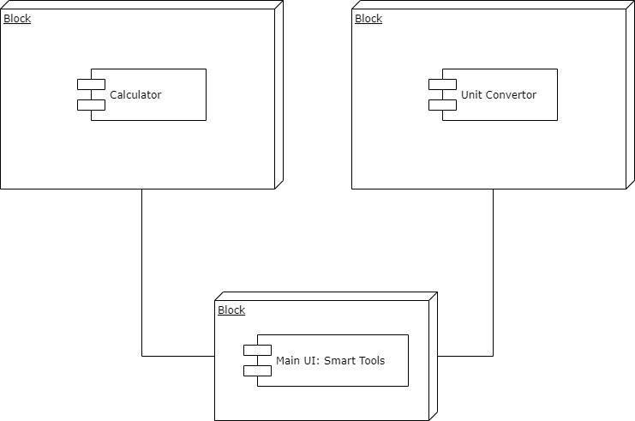

Figure 1: Component Diagram

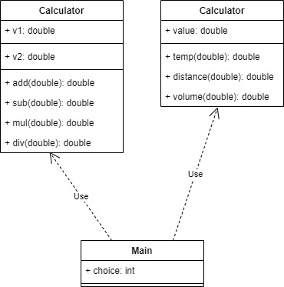

Figure 2: Class Diagram

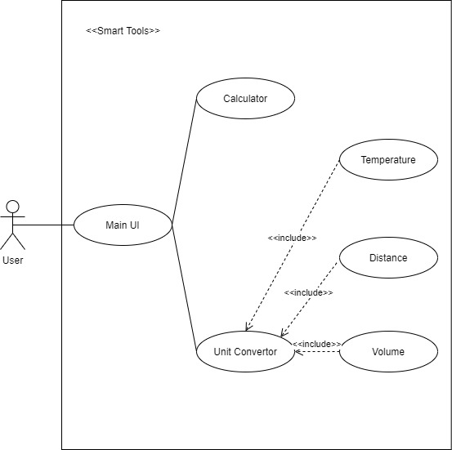

Figure 3: Usecase Diagram

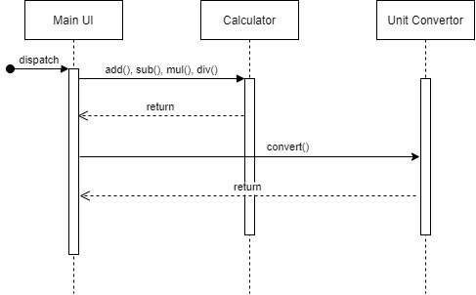

Figure 4: Sequence Diagram

# Test Cases

|  |  |  |  |  |  |
| --- | --- | --- | --- | --- | --- |
| Test Case ID | Description | Test Data | Expected Result | Actual Result | Pass/Fail |
| TC01 | Test Add Functionality of the system | 25, 65 | 90 | 90 | Pass |
| TC02 | Test Add Functionality of the system | 455, 911 | 1366 | 1366 | Pass |
| TC03 | Test Subtract Functionality of the system | 13589, 789 | 12800 | 12800 | Pass |
| TC04 | Test Multiply Functionality of the system | 144, 23 | 3312 | 3312 | Pass |
| TC05 | Test Divide Functionality of the system | 45, 5 | 9 | 9 | Pass |
| TC06 | Test Divide Functionality of the system | 66, 0 | Print “Can’t Divide by 0” | Print “Can’t Divide by 0” | Pass |

# Non-Functional Requirements

## Performance Requirements

The system should work with minimal hardware requirement. I should work with any basic machine that runs on Windows or Linux operating system.

## Safety requirements

The system should safely run on any machine without producing any damages to it. There should be mechanism to ensure that it doesn’t overflow the memory or processing power while operating it.